

July Health & Wellness Programs
RSVP for all programs. Programs with low enrollment may be canceled, so your RSVP helps us plan accordingly and ensures your favorite activities can take place.
410-358-6856 or info@myerberg.org

Vibrant Living Circle- Join us for a welcoming discussion group focused on healthy aging, meaningful connections, and personal well-being.
Monday, July 6, 2026,12:30-1:30 pm
Members Only Program

Red, White & Move! (July 4th Theme Class) Patriotic Chair Exercise!
Join Ilysa and celebrate Independence Day with a fun, festive chair-based exercise class featuring patriotic music and plenty of red, white, and blue spirit.
Monday, July 6, 2026, 2:00-3:00 pm
Members Free, Guests $5

Johns Hopkins Alzheimer’s Research Center joins us for an informative presentation on the latest Alzheimer's research, brain health, and available resources.
Tuesday, July 7, 2026, 1:00-2:00 pm
Members Free, Guests $5

Walk & Talk Wednesdays- Enjoy a relaxed and social walk at a comfortable pace. Perfect for those who like to take in the scenery, chat with friends, and stay active while enjoying the outdoors.
Wednesdays, July 8,15, 22 & 29, 10:00-11:00 am
Special Guest, Charm City Run on July 22, 2026

Sounds of Wellness: Hearing Screening Event-Join us for an informative program with Hear No More, offering hearing education and complimentary hearing checks.
Thursday, July 9, 2026, 10:00-11:00 am
Members Free, Guests $5

Hidden Hazards: Poison Safety Awareness- Maryland Poison Center will focus on staying safe at home. This informative session is designed to help you feel confident and prepared for everyday safety.
Monday, July 13, 2026, 2:00-3:00 pm
Members Free, Guests $5

Stay Safe in the Sun & Vaccine Clinic with Giant Pharmacy- Giant Pharmacy will focus on sun safety and protecting your skin during the warmer months. Following the presentation, they will also offer an on-site vaccine clinic to help you stay up to date on important immunizations.
Tuesday, July 14, 2026, 11:00 am-12:00 pm
Members Free, Guests $5

Move & Groove Bingo-This is not your average Bingo…
We will play a few rounds, pause to get up and move, and then jump right back into the action.
Monday, July 20, 2026, 1:00-2:30 pm
Members Free, Guests $10

Find Your Center: Meditation & Relaxation- Join JCS and take time to recharge with guided relaxation designed to refresh your mind and improve overall well-being.
Tuesday, July 21, 2026, 1:00-2:00 pm
Members $5, Guests $10

Join Ilysa & Layer It Up! Healthy Parfait Fun! Join us for a fun, hands-on class where you’ll layer Greek yogurt, fresh berries, and granola to create a healthy, delicious parfait. A simple, no-cook recipe packed with protein and antioxidants—perfect for a refreshing summer treat.
Monday, July 27, 2026, 1:00-1:45 pm
Members $5, Guests $10

Safe Meds, Healthy You- Join Pharmacy Ethics Education & Resources to explore medication safety, proper usage, and strategies for getting the most benefit from your prescriptions.
Monday, July 27, 2026, 2:00-3:00 pm
Members Free, Guests $5

Stretch & Reset- A gentle mobility and relaxation class with Ilysa Cohen in honor of International Self-Care Day. Stretch, breathe, and leave feeling renewed.
Tuesday, July 28, 2026, 2:00-3:00 pm
Members Free, Guests $5

International Friendship Day- Thursday, July 30, 2026
A day to recognize the importance of friendship in our lives. It’s a time to show appreciation for friends near and far, and to promote kindness, connection, and understanding across communities and cultures.

If you have any questions, please feel free to contact:
Ilysa Cohen
Wellness & Engagement Coordinator
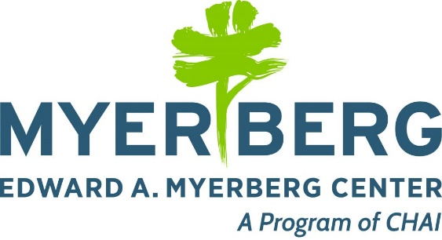
ilysa@myerberg.org

